Flight Readiness Report

Kent State University High-Power Rocket Club

Kent State University

Team Mentor: Mr. Steve Eves

Team Faculty Advisor: David B. Stringer, Ph.D.

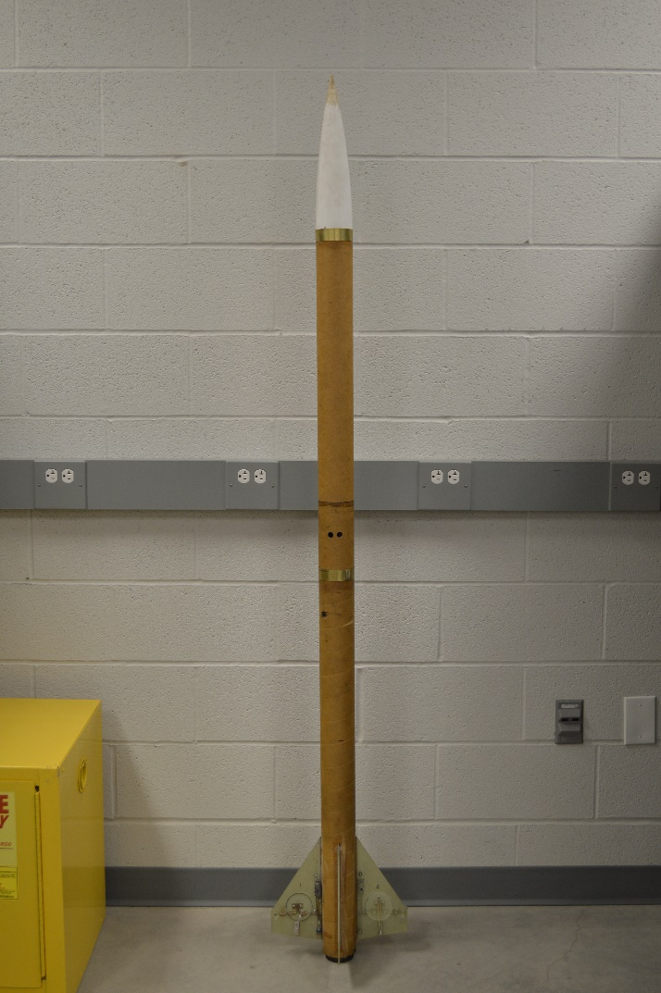dstring1@kent.edu 330.672.3953

Team Program Manager: Thomas Davis

tdavis81@kent.edu 440.822.5995

Team Members:

Maddie Wilson, Data Acquisition Co-Team Leader

Dakota Bunner, Data Acquisition Co-Team Leader

Robert Winkler, Structures Team Leader

Nelson Figueroa

Adam Fertig

Adrian Rivera

Matthew Alexander, Propulsions Team Leader

Jake Ennis

Richard Bray

Kaushik Anantha

Tyler Bodenschatz, Safety Officer

**Table of Contents**

Construction Materials/Techniques……………………………………………………………….3

Duel Deploy System…………...………………………………………………………………….4

Recovery System Test Launch...………………………………………………………………..........4

Predicted vs Actual Flight Performance with J415………………………………………………..4

Predicted Flight Performance with K550……………………………………………………...….6

Change Between J- and K-Class Motors……………………………………………………….…8

Ejection Charge System…………………………………………………………………………...9

Pre- and Post-Launch Procedures………………………………………………………………....9

Budget: Predicted v Actual……………………………………………………………………....10

Stability Analysis…………………………………………………………………………..…….10

**Figures and Tables**

*Figure 1: Actual J415 benchmark flight data*……………………...……………………....……...5 *Figure 2: J415 Predicted Height*………………………………………………………......…..….5

*Figure 3: J415 Predicted Velocity*………………………………………...………………….…...6

*Figure 4: K550 Predicted Height (Brake System Enabled*………………………………….....….7

*Figure 5: K550 Predicted Velocity (Brake System Enabled)*………………………………..........7

*Figure 6: K550 Predicted Acceleration (Brake System Enabled)*………………………..…….....8

*Table 1: Motor Specifications*………………………..........................................................……....9

*Table 2: Predicted Budget v Actual Budget*………………………………………..…………….10

*Table 3: Center of Gravity Calcuations*……………………………………….………..………..11

Drawing 1: Avionics Coupler Assembly…………………………………………………...……11

Drawing 2: Overall Rocket Design Dimensions…………………………………………………12

**Construction Materials/Techniques**

As the rocket is in the descent phase of flight, there are three distinct sections falling back toward the earth: bottom fin section, middle e-bay section, and upper nosecone, all connected by Kevlar shock cord. The materials used to construct our rocket were mostly bought through publicmissles.com, with some exceptions that came from apogeerockets.com. All tubes are phenolic material except for the electronics bay which was recently upgraded to fiberglass. The move towards a stronger material for the electronics bay came from the additional lead weights installed on the top and bottom of the electronics bay to limit the rocket performance in order to stay within our cleared airspace. Additional weight was also added to the plastic nosecone to better distribute the added weight.

The other part of the rocket that utilizes fiberglass material is the fin set. The 0.093 inch-thick fins provide the strength and support required for the drag system embedded in the rocket fins. There are two fins installed “as is”, however, the other two opposing fins each have a disk cut out of them. The disks are then reinstalled, but on a hinge approximately one-third of the way up the disk. When the “drag-disks”, as we call them, are deployed, the relative air against the asymmetrically deployed drag-disks, keeps it open until an elastic band overpowers the force of the wind as the rocket nears apogee.

The idea of the drag-disk system seems easy to employ at first, but proved to require much thought and development. An original electro-mechanical device was to deploy the drag-disks. However, a purely mechanical system was developed, relying on the physics of rocketry, instead of relying on a cheap hobby servo. The mechanical system relies on a lead sled, one on each fin, that locks the drag-disk in place while the rocket is accelerating (motor burn phase), and allows the drag-disk to open when the rocket experiences negative acceleration due to drag (post motor burn phase). Utilizing the inertia of the lead sled has led to the drag system deploying consistently ever since our second attempt’s addition of a hard stop to restrict the movement of the sled, keeping it from jamming. The lead sled also sits on a spring that helps, along with the negative acceleration, to move the lead sled back to its starting position. The last major element that makes up the air braking system are the small tabs that are connected to the drag-disks. These small tabs are positioned at a right angle to the fin to allow for the initial opening of the drag disks. Once the small tabs begin the drag deployment, the one-third axis offset opens the disk the rest of the way. A great visual que that the system has deployed is the slight, slow spin of the rocket due to the slightly asymmetrical geometry during the air-braking event.

The construction of the rest of the rocket was much easier than the drag system. The 54mm motor mount was installed with three centering rings and plenty of 5-minute epoxy. The only issue was that our decision to use a 3 inch body tubing with a 54mm motor left us with very little room for installing the hardware to attach the drogue chute. The solution was to use two smaller eye-bolts with a cable ran though both to distribute the load from the 18” drogue chute deployment. The metal cable solution was chosen due to its ability to withstand the mandatory backup charge in the motor. Kwik Links were also used for convenience on both top and bottom sections of the rocket. The electronics bay is installed into the upper body tube, below the 72” main parachute. The electronics bay and the upper body tube are secured with two plastic rivets, whereas the electronics bay and lower body tube are secured with two small shear pins. The nosecone is also secured to the upper body tube with two small shear pins that are replaced after every flight. Both chutes are protected by the Nomex sheets wrapped around them. The addition of two 10x10 airfoil shaped rail buttons and a 54mm threaded motor retainer finish off the structural composition of the rocket.

**Duel Deploy System**

The StratoLogger duel deployment altimeter has been extremely reliable, allowing for 100% success in the ignition of all drogue and main chute charges. Our electronics bay houses two StratoLoggers to allow for a backup to be ready for use, as well as to be utilized as another source of flight data. The most significant “lessons-learned” with respect to the duel deploy system is associated with the physical ejection charges. Originally, we used small medical centrifuge caps to store the charges, but the directional blast blew the small plastic capsule horizontally half way through the rocket body. The solution to this problem was to use less rigid plastic with a vertical blast orientation. The carful wiring of the charges during pre-launch setup, and the three-beep continuity audible check during final pre-launch procedures have led to a consistent drogue chute deployment at apogee and main chute deployment at 700 feet AGL.

**Recovery System Test Launch**

Prior to test launching our rocket, lead weights were added to the top and bottom of the electronics bay for added stability.  The rocket’s descent rate was not taken into account upon adding the weights.  The main chute utilized at the time was 54 inches in diameter.  Due to the rocket’s weight exceeding that of our descent rate equation (Eqn. 2), the Altimeter Two recorded readings of a descent rate 24fts.  The rapid rate of descent paired with the added weight of the rocket caused the electronics bay coupler to crack upon impact with the ground.  Realizing the problem, adjustments were made to the weight to descent velocity ratio equation (Eqn. 1).  A 72 inch main chute was utilized for the remainder of the test flights to account for the added weight.  Descent reading s from the Altimeter Two, when using a 72 inch main chute, proved our descent velocity calculations to be accurate.  The data showed that our target descent rate of 24fts had been reached.

d=8mgπρCDV2   **(Eqn. 1)**

d ≥ 16.7WπρCD **(Eqn. 2)**

**Predicted vs Actual Flight Performance with J415**

The actual apogee of the J415 flight with the braking system stowed was recorded by the StratoLogger to reach a benchmark apogee of 3,691 feet AGL with a maximum speed of about 540 fps.

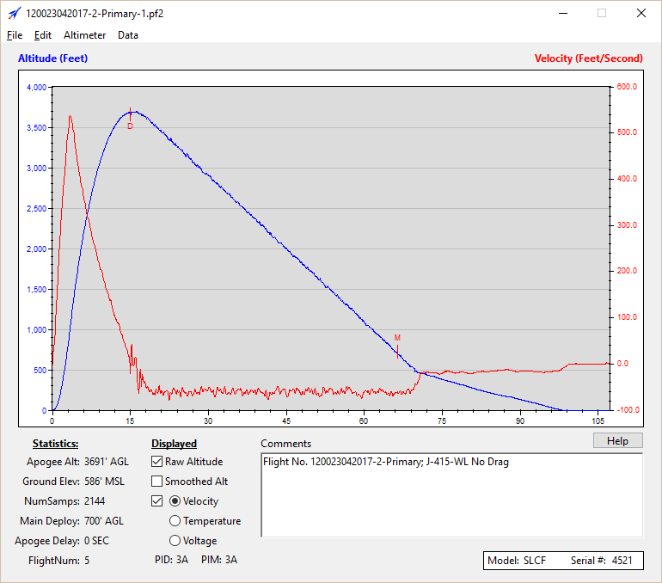

*Figure 1: Actual J415 benchmark flight data*

The Matlab code originally predicted an altitude of 4,340 feet AGL with a maximum velocity of 650 fps. Since the drag system hardware imposes excess drag, the originally estimated coefficient of drag for the rocket was increase until the resulting calculated apogee was close to the actual apogee. This reverse calculation is a common way for rocketeers to hone in on the coefficient of drag of their rocket. In our case, the estimated 0.80 coefficient of drag was increased to 1.185, yielding a new apogee of 3,635 feet AGL (1% error) and a maximum velocity of 620 fps (15% error).

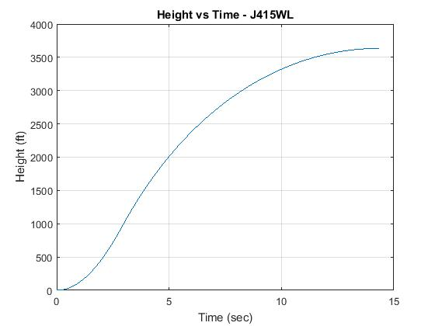

*Figure 2: J415 Predicted Height*

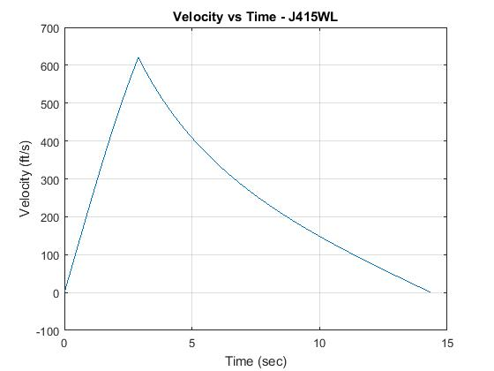

*Figure 3: J415 Predicted Velocity*

The main reason for any error in the Matlab calculations are due using average thrust values instead of actual thrust data (an improvement to come in future versions of the code). However, the code is able to predict the K-motor flight using the adjusted coefficient of drag to, hopefully, within the same tolerance as the J-motor flight.

**Predicted Flight Performance with K550**

Only predicted flight performance for the K550 flight is provided in this report due to various reasons, however, the K-motor launch will occur the day after the fight readiness report due date. Since weather conditions limited our access to the launch field, our progressive launch schedule was affected. The first launch day was the drag system verification on small motors and the second launch day was for adding weight and setting a J-motor benchmark. The soon-to-be third launch day is to test the K550 flight performance with the drag system enabled. The progress step-ups in motors was for the safety of all involved. Also, if the drag system did not deploy properly, the team was concerned that our rocket would go higher than our allowable cleared airspace.

The drag system is predicted to take a no-brake flight on the K550 from 4,507 feet AGL down to a braked flight apogee of 3,731 feet AGL. Comparing the braked flight to the J415 benchmark flight yields a 1% deviation. This prediction is calculated using the current total disk area of approximately 14 square inches. For increased adaptability, the two drag fins have been modified to accept 30% larger drag disks if required.

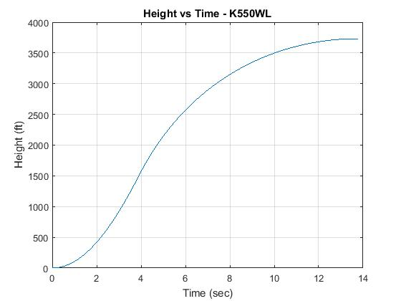

*Figure 4: K550 Predicted Height (Brake System Enabled*

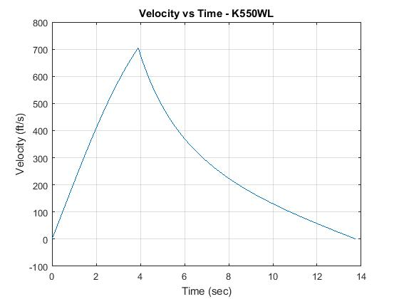

*Figure 5: K550 Predicted Velocity (Brake System Enabled)*

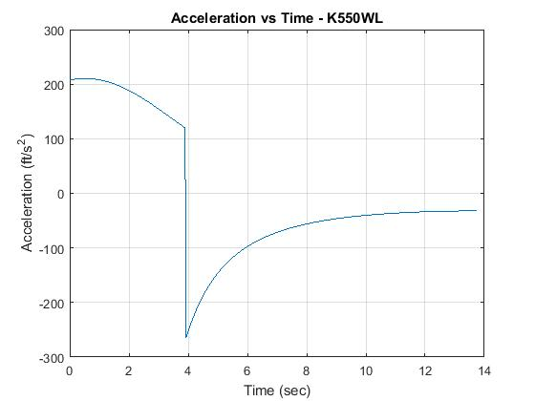

*Figure 6: K550 Predicted Acceleration (Brake System Enabled)*

Figures 4 through 6 represent the predicted flight performance of the K550 flight with the drag system deployed immediately after motor burnout. The acceleration graph (Figure 6) further expresses the theory behind the functionality of the drag system: it is easy to see that at 3.9 seconds (motor burnout time) the positive acceleration that keeps the drag system closed jumps to negative acceleration almost instantly, which deploys that airbrakes.

Further evidence that our drag system will be effective is the second J415 flight with the drag system enabled. A flight that would otherwise have reached about 3,691 feet AGL for a second time, was brought down to 3,035 feet AGL, a drop of 656 feet (or about 17.8% decrease). Since a no-brake K550 flight is predicted to reach 4,507 feet AGL, the ideal decrease in apogee due to braking is 816 feet (or about 18.1% decrease), a similar feat to the actual J-motor drag system performance.

In addition to drag system performance, the rocket must also abide by competition rules. Although weight was added to the rocket, a thrust-weight ratio of 8.18 for the J415 and 7.46 for the K550 is achieved (well above the required 3 to 1 ratio). Also, a rail departure velocity of over 107.0 fps for the J415 flight and over 102.6 fps for the K550 flight is predicted (well over the required 45 fps for an 8-foot rail).

**Change Between J- and K-Class Motors**

The engines originally estimated to be used for the competition were the J300LR and the K527LR, both manufactured by Loki Research. These motors had posed serious safety risks, and were ultimately ruled out, because of the lack of a delayed fuse in the igniter. Since nearly all Loki motors involved the same plugged ignition, attention was put onto Aerotech’s line of J- and K-Class motors. Due to time constraints, adverse weather conditions of test-flight cancellations, and limited options of motors, the J415W engine was chosen to “set the bar” at an altitude at roughly 3,600 feet AGL. This was short of the original key performance parameter of 4,000 feet AGL, so a decrease in points for altitude was inevitable.

However, the addition of the Aerotech K550W provides a presumably-safe approach to test the “drag-disk” drag system, providing normal weather conditions, resulting in a predicted altitude of approximately 3,700 feet AGL once the drag system was deployed (*Fig. 4)*. While the average thrust and total impulse of the K550W is only 113 N and 393 N-s higher, respectively, the target altitude with the drag system activated should end up being very precise, within an estimated 3-4% tolerance.

***Table 1: Motor Specifications***

|  |  |  |  |  |
| --- | --- | --- | --- | --- |
| **J-415-WL** | |  | ***K-550-WL*** | |
| Manufacturer | Aerotech |  | Manufacturer | Aerotech |
| Designation | J415W |  | Designation | K550W |
| Casing | RMS 54/1280 |  | Casing | RMS 54/1706 |
| Outside Diameter | 0.054 m |  | Outside Diameter | 0.054 m |
| Total Length | 0.326 m |  | Total Length | 0.410 m |
| Total Impulse | 1201 N-s |  | Total Impulse | 1594 N-s |
| Average Thrust | 343 N |  | Average Thrust | 456 N |
| Peak Thrust | 552 N |  | Peak Thrust | 853 N |
| Burn Time | 3.50 s |  | Burn Time | 3.50 s |
| Propellant Mass | 0.660 kg |  | Propellant Mass | 0.880 kg |
| Motor Mass | 1.199 kg |  | Motor Mass | 1.515 kg |
| Propellant Type | White Lightning |  | Propellant Type | White Lightning |

**Ejection Charge System**

The original usage of the ejection charge canisters had caused a major problem that needed corrected to make any future launches flight-ready. As mentioned earlier, the plastic centrifuge caps had blown holes straight through the phenolic tubing of the rocket body. To correct this, paper was folded into a pouch and taped, with the black powder and igniter wire tucked inside. While this had fixed the issue of the penetrating blast, there were questions and concerns of the paper’s integrity to contain the black powder without spillage.

To enhance the support of the ejection charge, straws will instead be used. Specifically, thick straws were cut into small segments that were measured to fit the top of the avionics bay, where it will be attached. One opening of the straw would then be glued together, which forms the bottom of the charge, and the top is taped together, after 1.5 grams of black powder (calculated using Pascal’s Law), as well as the ignition wire, were placed inside.

**Pre- and Post-Launch Procedures**

Prior to launching, the team had strictly followed the checklists located in the appropriate sections—beginning with the *Safety Items Checklist,* completed by the Flight Safety Officer, followed by the *Pre-Launch Checklist*, and the *Launch Pad & Flight Arming Checklist*, completed by their respective teams. These checklists ensure that consistency is held throughout the entirety of the project, creating traceability to fix any problems that should occur; they are also used to prevent hazards, keeping the frequency and severity of risk occurrences as low as possible.   
  
In addition, our club mandate requires multiple team members helping for any one task, as both personal safety and observation are of paramount importance. In doing so, possible concerns are more readily encouraged by multiple members with adequate hands-on experience, problem-solving becomes more efficient, and more observations useful to data-taking occur.

**Budget: Predicted v Actual**

***Table 2: Predicted Budget v Actual Budget***

|  |  |  |  |  |
| --- | --- | --- | --- | --- |
| ***Proposed Budget Delegation ($10,000)*** | | | | |
| **Delegated Component** | **Estimated Budget [$]** | **Budget Percent [%]** | **Actual Budget [$]** | **Budget Percent [%]** |
|
| Travel/Lodging | 3,000 | 30 | 2869.17 | 28.7 |
| Lab Space/Overhead | 500 | 5 | 500 | 5 |
| Prototyping | 500 | 5 | 81.73 | 0.81 |
| Instructor Mentorship | 1,200 | 12 | 1200 | 12 |
| Reports/Documentation Supplies | 100 | 1 | 98.4 | 0.98 |
| Propulsion | 1,200 | 12 | 1270.69 | 12.7 |
| Structures | 1,200 | 12 | 1140.19 | 11.4 |
| Data Acquisition Components | 1,500 | 15 | 1630.75 | 16.31 |
| Registration Fee | 400 | 4 | 400 | 4 |
| Hardware/Software | 400 | 4 | 340.05 | 3.4 |
| Misc | 0 | 0 | 469.02 | 4.7 |
| TOTAL | 10,000 | 100 | 10000 | 100 |

**Stability Analysis**

The center of gravity is located at approximately three inches forward of the center of pressure, located at 55 inches. This gives us a static margin of just over one. This indicates a stable rocket within competition parameters.

***Table 3: Center of Gravity Calcuations***

|  |  |  |  |
| --- | --- | --- | --- |
| ***Center of Gravity (From Tip of Nose Cone)*** | | | |
| **Component** | **Location [m]** | **Weight [kg]** | **Moment Arm [kg*m]** |
| Nose Cone | 0.248 | 0.55 | 0.136 |
| Upper Body | 0.624 | 0.23 | 0.144 |
| Lower Body | 1.737 | 1.23 | 2.137 |
| Main Chute | 0.495 | 0.35 | 0.173 |
| Droque Chute | 1.216 | 0.22 | 0.268 |
| Avionics Coupler | 0.997 | 1.88 | 1.874 |
| J Motor | 1.827 | 1.859 | 3.396 |
| K Motor | 1.785 | 2.395 | 4.275 |
|  |  |  |  |
|  | **Moment [m]** | **Moment [in]** |  |
| J Motor | 1.286 | 50.6 |  |
| K Motor | 1.314 | 51.7 |  |

*Drawing 1: Avionics Coupler Assembly*



*Drawing 2: Overall Rocket Design Dimensions*

